
Story

Date | 29 July 2026
Team ID | Rithika C
Project Name | India's Agricultural Crop Production Analysis (1997–2021)
Maximum Marks | 5 Marks

Activity 1: Story Design:

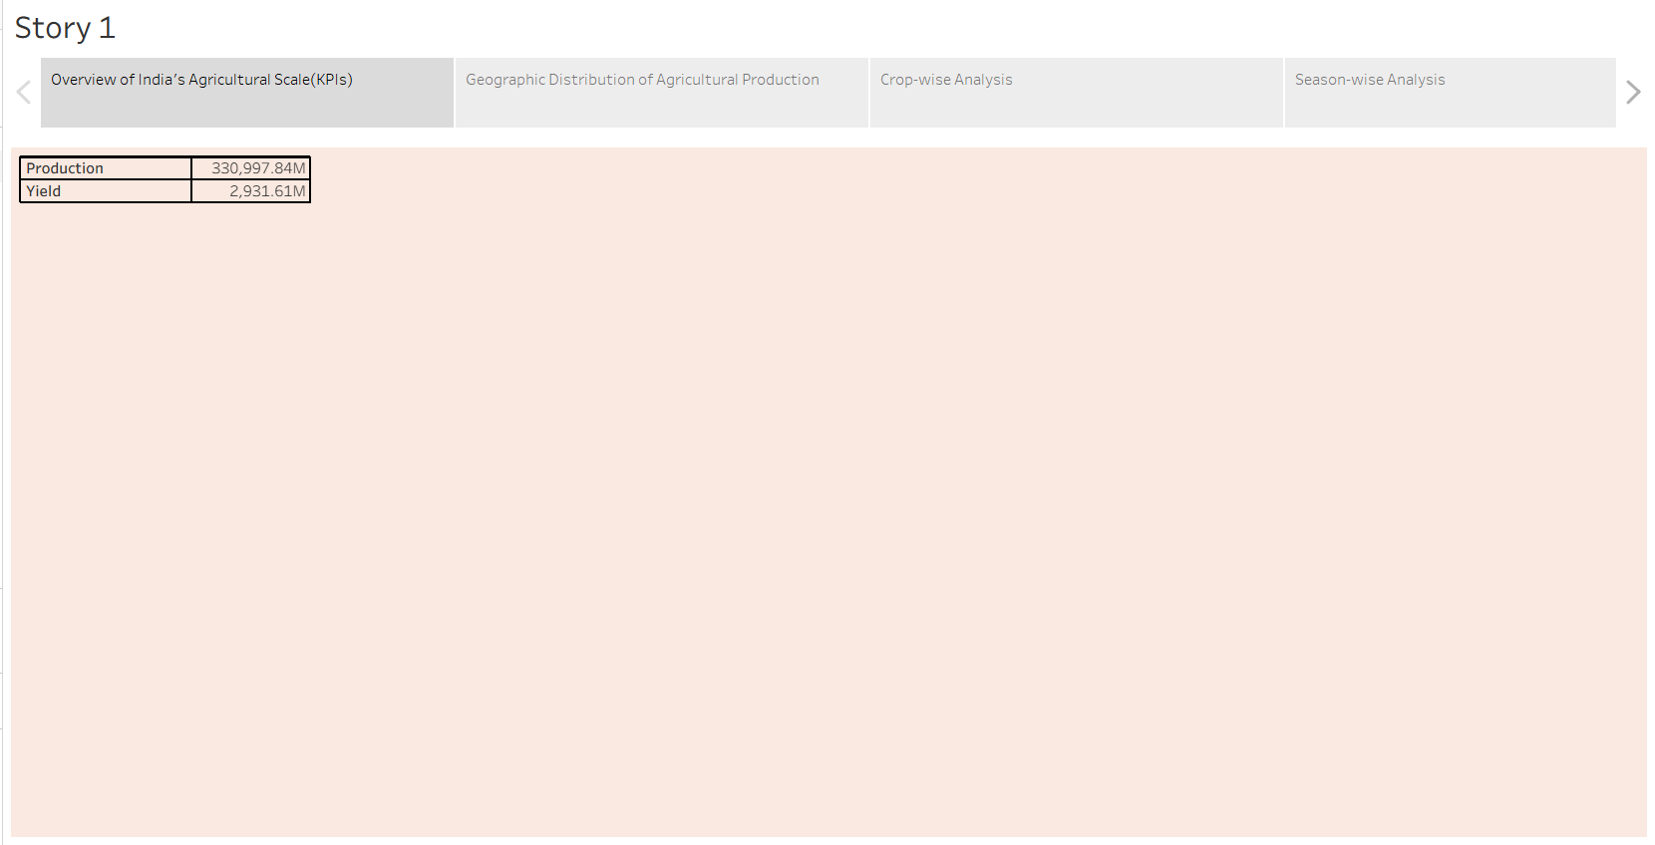

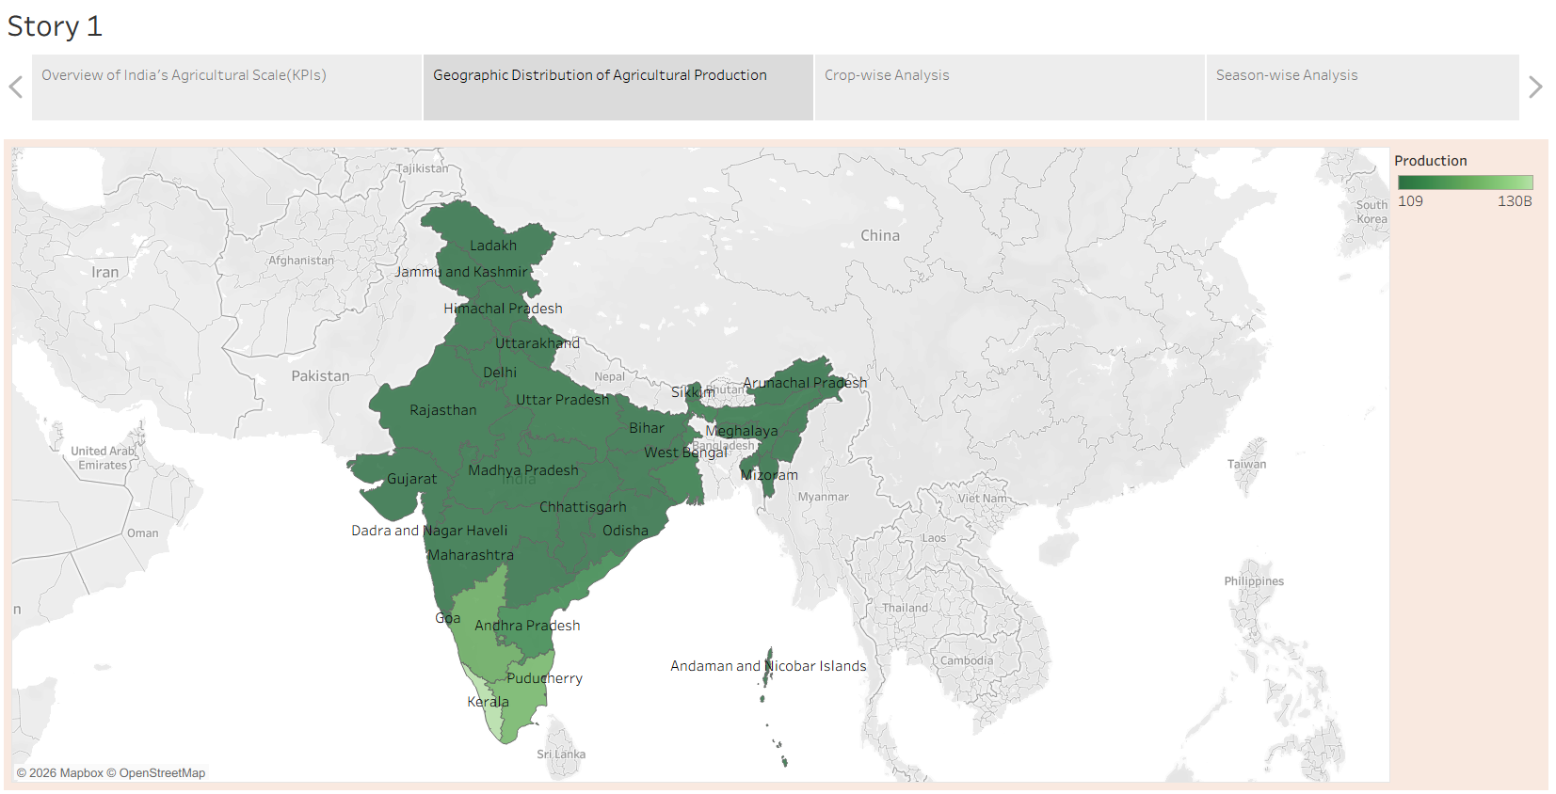

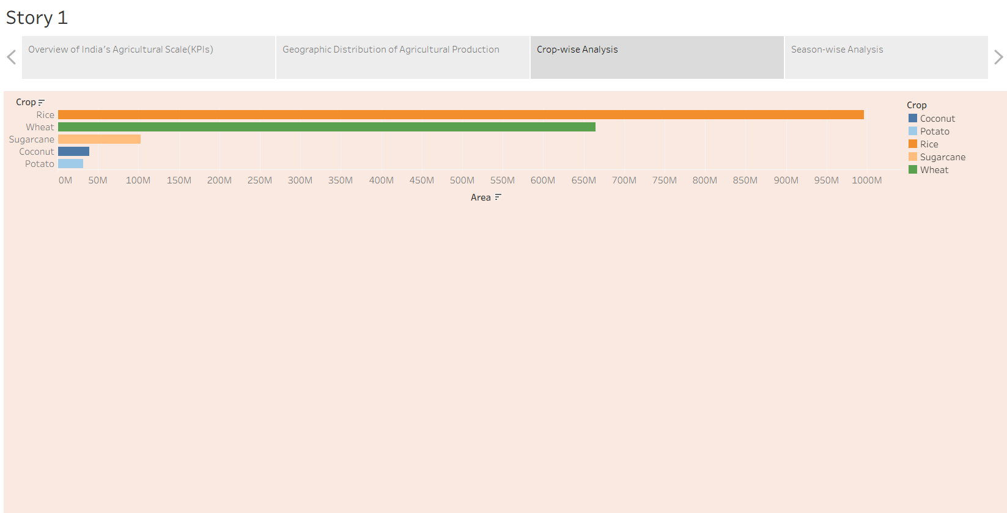

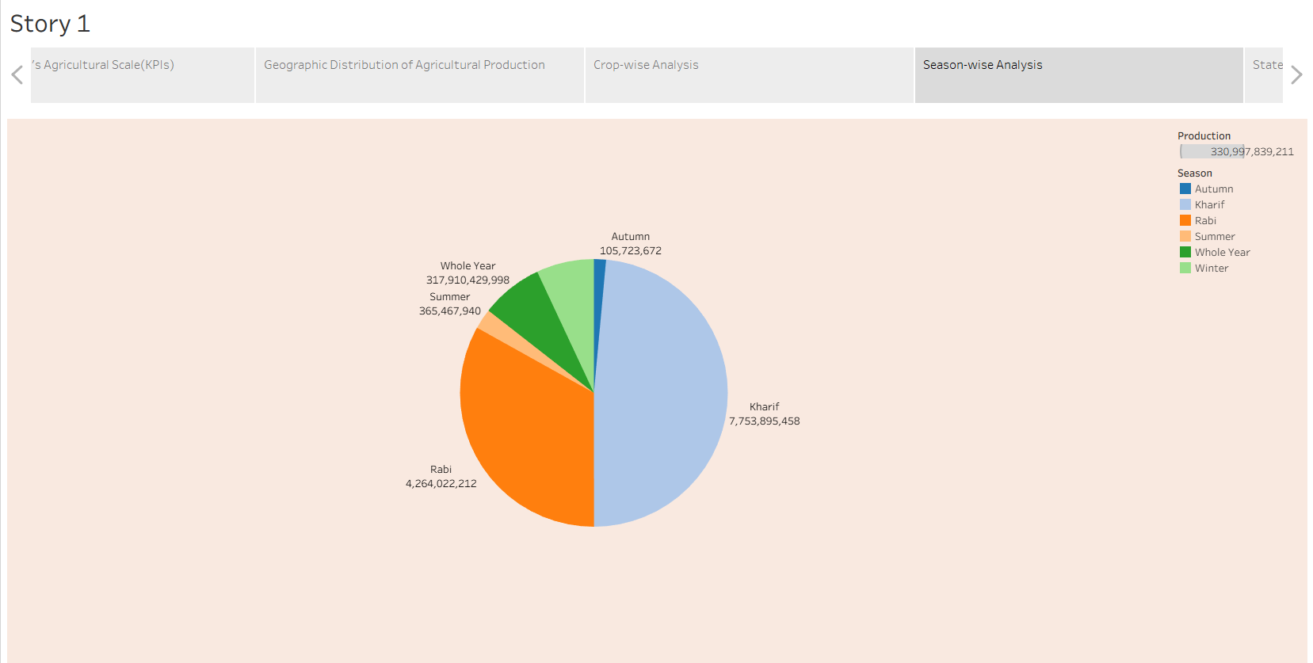
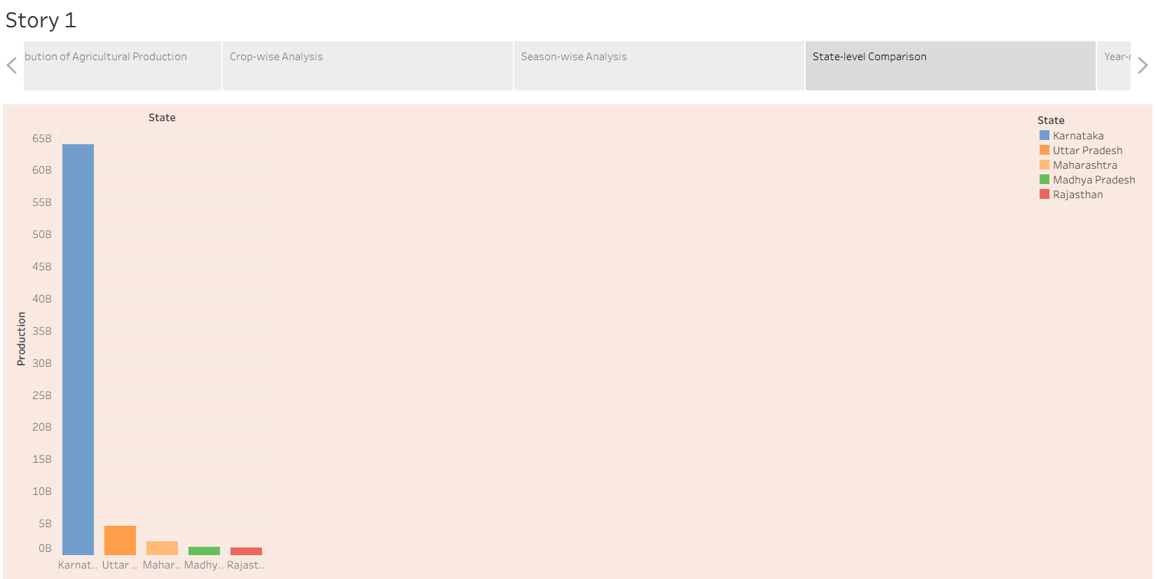

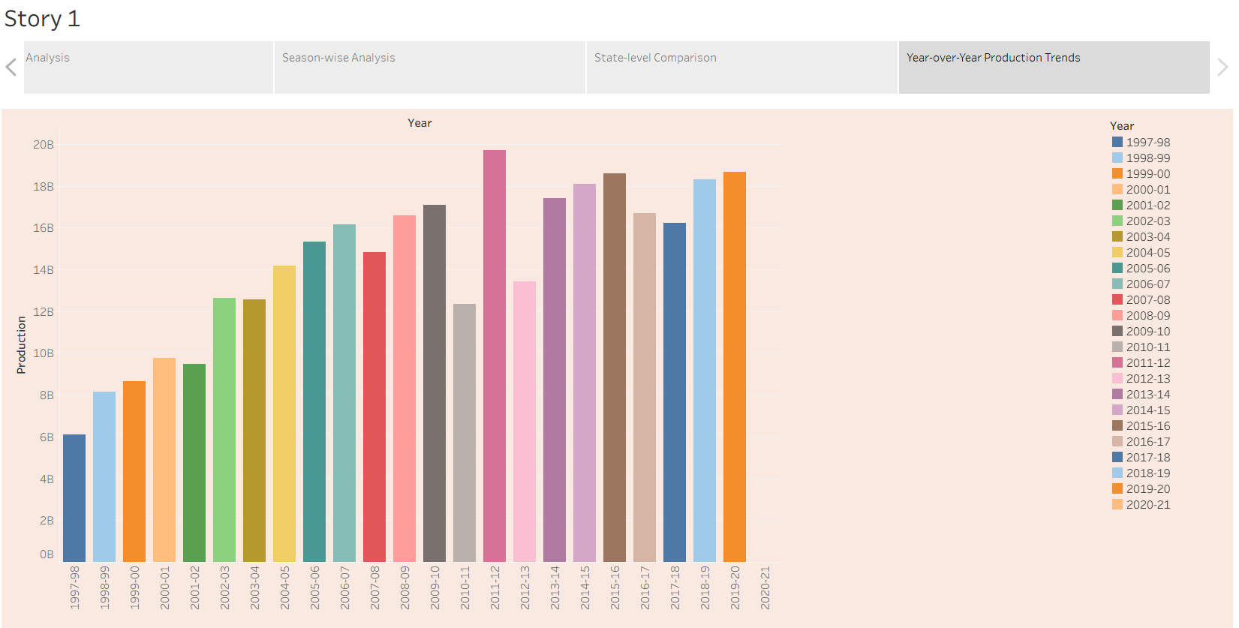

Tableau Story Narrative & Observations
By leveraging the sequential story point structure in Tableau, the India's Agricultural Crop Production Analysis presentation guides users through a logical progression of agricultural production insights, transforming raw crop production data into a comprehensive and interactive analytical narrative. The story enables stakeholders to explore agricultural performance across different states, crops, seasons, and years, supporting data-driven understanding of India's agricultural landscape.
Based on the interactive story points, here are the core agricultural observations:
- State-wise Agricultural Production Analysis (Q3 & Q6): The geographical map and state-wise production charts reveal significant variations in agricultural production across Indian States and Union Territories. Certain states consistently contribute a larger share of total production, highlighting regional agricultural strengths and production capacity.
- Crop Cultivation and Land Utilization (Q4 & Q5): The cultivated area visualizations demonstrate considerable differences in land utilization among various crops and states. These comparisons help identify crops occupying the largest cultivated area and regions with extensive agricultural activities.
- Seasonal Agricultural Production Distribution (Q9): The season-wise production visualization illustrates the contribution of different agricultural seasons to India's overall crop production. The story highlights how seasonal variations influence production patterns and overall agricultural output.
- Historical Agricultural Production Trends (Q2 & Q7): The year-wise production visualizations present long-term agricultural production trends from 1997 to 2021, enabling users to observe production growth, annual fluctuations, and historical changes in agricultural performance over the study period.
- Comprehensive Agricultural Performance Overview (Q1 & Q8): The KPI cards and production distribution visualizations provide a consolidated overview of India's agricultural sector by summarizing key production indicators and production unit distributions. Combined with interactive filters, the Tableau Story enables users to perform dynamic analysis based on State, Crop, Season, and Crop Year, offering a comprehensive understanding of agricultural production across India.

Activity 2: Publish Story on Tableau Public and Paste Public Link Below
Tableau Public Story Link:
https://public.tableau.com/app/profile/rithika.c3948/viz/IndiasAgriculturalAnalysisStory/Story1

